Title: Uncertainty in preschooler’s intuitive theories of biology, psychology, and psychosomatic events drives explanation seeking

Authors: Yang Yang, Elizabeth Bonawitz*, & Carla Macias

*Presenting author

Research has demonstrated that children will choose to explore options with “highest learning payoff” as measured by information gain. However, information gain also depends on a learner’s beliefs: the same exploration could contain lower gain for a learner with a strongly-held belief about the outcome, as compared to a learner who had greater uncertainty over possible outcomes.

Here we look a preschooler’s information seeking behavior as a consequence of the certainty of their beliefs in a “choose-your-own-adventure” paradigm. We investigate cases when uncertainty is caused by a lack of evidence and weakly held beliefs, and cases when uncertainty is caused by strongly held beliefs conflicting with evidence. 54 children (M=59.5mos, R=44-77mos) participated in all tasks across a two-week testing period. Seven additional children were dropped due to attrition (2) or “yes bias” (5), and 11 children were dropped from the False-belief condition, due to an error in the initial method for the pre-test books. Batteries about germ transmission, false-beliefs, and psychosomatic events were given in week 1, with the “choose-your-own-adventure” test books given week 2.

We designed Germ and False-belief books so that they did not provide strong evidence for the outcomes in the books. In the Germ book, a character with a cold played with a friend. Participants could choose to learn whether the other character contracted the cold, or they could learn an unrelated event (which of two games the character chose to play). In the False-belief book, the main character hid a toy, which was moved while they were out of the room; the participants could choose to learn where the character went first to look for her toy when she returned, or an unrelated outcome (which of two friends was knocking at the door). We performed a median split based on pretest scores by domain, and compared domain-choice responses to non-domain choices. Children with earlier developing domain knowledge (lower pretest scores) were significantly more likely to choose the domain outcome (66%) than children with established domain knowledge (47%), Fisher exact *p*=.045.

In the Psychosomatic book, we looked at the interaction of theories with evidence by presenting statistically ambiguous, but likely evidence in favor of the psychosomatic event (see Schulz, Bonawitz, & Griffiths, 2007). At the end of the book, children could choose to learn about what variable was causing the character’s tummy-ache, or they could learn about an unrelated event. Maximum uncertainty is created by the interaction of the evidence and strongly held beliefs against psychosomatic events. As predicted and after receiving statistically surprising evidence, children who strongly rejected psychosomatic events initially (N=15) were significantly more likely to choose to hear the domain-relevant variable (73%) as compared to children who already believed these events were possible (N=39; 44% domain choice), Fisher exact *p*=.048.

Critically, across all conditions, age did not predicted preference (R=-.11, *p*=*ns*), but instead preference depended on children’s domain knowledge as measured by the pretest batteries. Taken together, these results suggest that children seek out explanations in situations in which they are likely to maximize information gain. Critically, this gain depends on the interaction of the strength of children’s beliefs and the potential evidence to be observed.

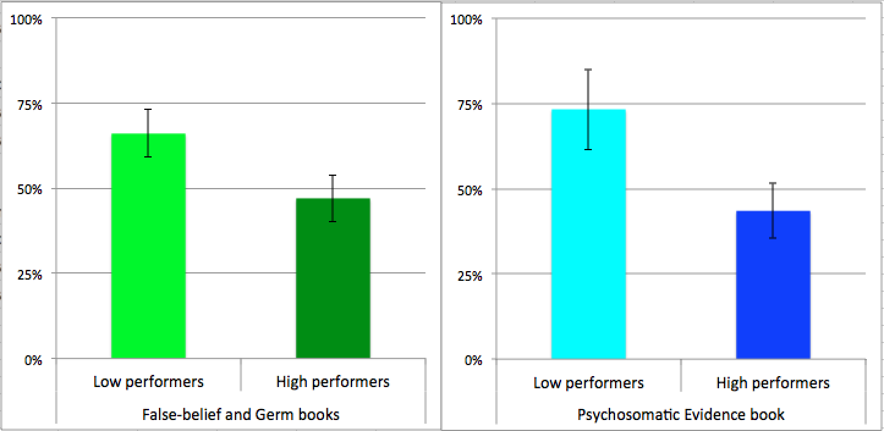

**Fig.** In the test books,children were significantly more likely to choose to hear the domain-relevant outcome (over the irrelevant outcome) if their beliefs were less established (as measured by performance on the domain batteries in week 1).